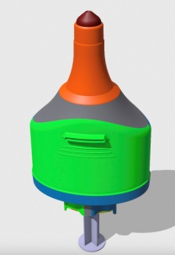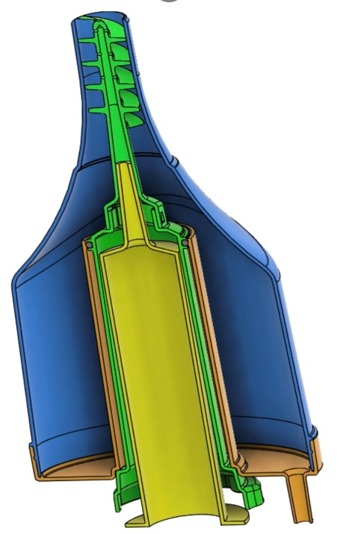

**FDA Classification: Class I (Exempt)**

**Device Product Code: Gastroenterology-Urology – FFP – Dilator, Rectal (510(k) exempt)**

**Manufactured to: ISO 9001 Standards**

* Safe and effective
* Easy to use
* Smooth introducer
* Stool containment
* Remover only contacts stool
* Clear container for optimal visualization
* Invented from 35 years of ED experience

Need

Device

Benefit

* Dramatically improves the quality of treatment, reducing discomfort for the patient.
* Saves time and cost by reducing a long visit to minutes and avoiding admissions.
* Safe and simple to use by any level of health care provider.
* Increases nursing satisfaction by enabling a humane approach to this difficult problem.
* Out competes other impaction removers by design
  + Comfortable introducer
  + Remover cannot touch mucosa
  + Irrigation cleans tool insitu
  + Stool stays contained

Fecal Impaction Is A Growing Health Issue In America Contributing Factors Include

* Low fiber diets
* Reduced Physical activity
* Medications
* Opiate epidemic
* Aging population
* Those with disabilities

**Video demonstration at** [**F-Cal.com**](http://F-Cal.com)

There have been no significant improvements in the treatment of fecal impaction.

Traditional treatments often involve

laxative stimulants increasing the pressure above the obstruction which can cause pain, delay and serious complications

The Needed Solution:

* Addresses the problem directly
* Minimizes patient discomfort and embarrassment
* Enhances treatment efficacy
* Streamlines the care plan

**It is time for a change in the**

**Standard Of Care.**