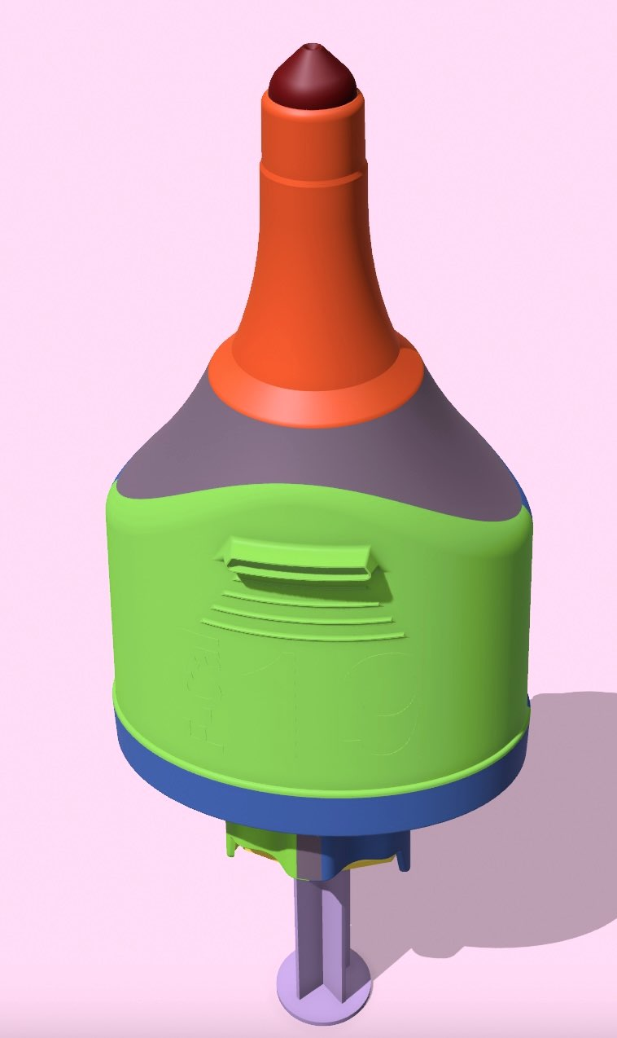

**F-CAL**

**17101 Albion**

**Detroit, MI 48234**

LETTER FROM THE DESIGNER:

Having worked as an ED physician for 35 years I never found an efficient tool for removing a fecal impaction.

The idea for the F-CAl device occurred to me while doing a digital dis-impaction years ago.

I had considered devices that just poked in to disrupt the structure of the impacted stool and others that were screw like but I worried about damaging the rectal mucosa.

It was also evident from my experience that some impactions are so sticky that any tool will become clogged. The irrigation feature was created to solve this problem.

I felt we needed an easy way to penetrate a spasmodic rectal sphincter.  Comfort of use, ease and safety while removing actual stool volume became my goals.

I wanted a device that would be intuitive enough for any experienced care provider to use without specific training and without the potential for injury regardless of how it was used.

The result is a safe, simple device that by reducing the volume of stool will allow for a natural less painful passage of the remainder of stool.

*Patrick Munson MD*

**It Is Time For A New Solution To this Old Problem**

Introducing

**F-CAL DEVICE**

Fecal Impaction Removal Tool

Learn More

Please visit at [www.f-cal.com](http://www.f-cal.com)

QR to access video demonstration at [F-Cal.com](http://F-Cal.com)

Contact us:

Ordering information:

Customer service: 313-469-7022

Medical Use Questions:

Dr. P Munson MD 734-646-1368

All Other Questions:

Dr. L Nelson PHD 313-472-8661